Implementation of a Video On-Demand
System For Cable Television

Specific VOD Implementation for one way networks

This white paper is co-authored by:

Teleste Oyj

Edgeware AB

TABLE OF CONTENTS

Confidentiality notice | 2
About this document | 2
Video on demand system for cable television | 3
Low cost hybrid approach | 4
System description | 4
Summary | 8
Appendix 1: Edgeware distributed delivery architecture | 9
Appendix 2.Teleste MyCast hybrid tv solution | 14
Appendix 3.Teleste MyCast screenshots | 17

Confidentiality notice
This document is confidential and may not be reproduced, distributed or used for any purpose other than by the recipient for the assessment, evaluation and use of Teleste or Edgeware products and services unless written permission is given in advance by Teleste Corporation or Edgeware AB.
About this document
This document provides an overview of a hybrid system developed by
Teleste using components and systems from various suppliers including Edgeware AB to provide a video on demand solution for cable providers. It is not intended to provide in-depth technical information, which is available in Teleste and Edgeware technical documentation

VIDEO ON DEMAND SYSTEM FOR CABLE TELEVISION

Background
With the opportunity for on-demand premium services growing at a significant rate, these types of services such as on-demand, or catch-up TV and video on demand (VOD) offer the cable TV operator the ability to roll out new services and content to their subscribers. The goals associated with this are clear:
- Offer additional premium revenue generating services aimed at those services that subscribers already have a propensity to pay for
- Reduce subscriber churn and attract new subscribers by offering new and differentiated services
- Keep the investment in both infrastructure and content to the minimum possible and avoid “investing forward” in both network and user infrastructure.
With these goals in mind Teleste and Edgeware, the leaders in distributed video delivery, have co-developed a technology solution, which enables easy implementation of video on demand (VOD) in digital cable television network. The system enables to provide content directly to existing digital TV receivers, and therefore also to customers whose receiver is not bidirectional.

Operator perspective
In Finland, the solution covered in this paper, developed by Teleste and incorporating Edgeware technology, was first implemented by Turku Cable Television Ltd., which in April 2010 launched the pilot service for cable based Video On Demand (VOD) in the Turku area. Once fully deployed the service will expand to cover all the operator's cable-TV customers. The VOD video billing is happening in the same monthly bill as pay-TV packages.
The comprehensive hybrid solution from Teleste and Edgeware makes the implementation of a VOD service simple for the operator and easily usable by the end-user.

Low Cost Hybrid Approach
The new solution allows the VOD service to be used without any additional hardware at the consumer end. Video on demand is watched from the current digital TV receiver while video selection and video controlling is done with a PC or a mobile device.
The Teleste MyCast hybrid TV platform enables this VOD service.
MyCast connects to the video content, the Conditional Access System (CAS) as well as subscriber management and billing systems. MyCast also creates the consumer VOD portal, offers video playback and controls the cable television network capacity utilization.
The other key part of the system is developed by Edgeware. The video server Orbit-2X is used to play video via the cable television network to the customer's digital receiver. Video playback control commands transmitted from the viewer’s PC or mobile to MyCast is further forwarded to the video server. The features of the Edgeware’s Distributed Delivery Architecture will be featured in Appendix 1.
The system is easily accessible and intuitive to the viewer. The movie is selected and ordered from the web portal, which also directs the viewer to the right channel. After the user changes the channel, watching the video can start almost immediately when the authorization has been delivered to the digital receiver through the cable TV network. It is possible to control video playback with standard VCR-like buttons, which open on the VOD portal web page.

System description
The VOD solution consists of:
- Teleste MyCast hybrid TV solution
- Support for delivering VOD movies over cable (QAM) or over IP (e.g. DSL or cable modem).
- Management of VOD assets and their metadata.
- Dynamic VOD portal generation based on VOD metadata • Management of QAM resource usage i.e. video channel allocation.
- Edgeware Orbit-2X VOD server.
- Interface to operator’s Subscriber Management System (e.g. for ordering and billing VOD titles).
- Interface to operator’s Conditional Access System which must support VOD pre-encryption.
- VOD Portal for PC, mobile device and interactive set top box (STB) running Teleste MyCast
- Media Player for playing and controlling VOD videos. Player UI is available for PC, mobile device and STB.
- Possibility to play, pause, stop, fast forward and rewind VOD movie during playback

System diagram

A key component of the solution developed by Teleste is the Edgeware Orbit-2X platform that provides the distributed video delivery functionality. The Orbit-2X platform is a highly scalable, very small form factor video distribution system that allows in-network caching of content and video distribution that drastically reduces the cost of video servers and also the latency associated with providing this type of content across the cable provider’s core network

The developed system can be used with the standard and common digital cable receiver, i.e. DVB-C zapper set-top-box.
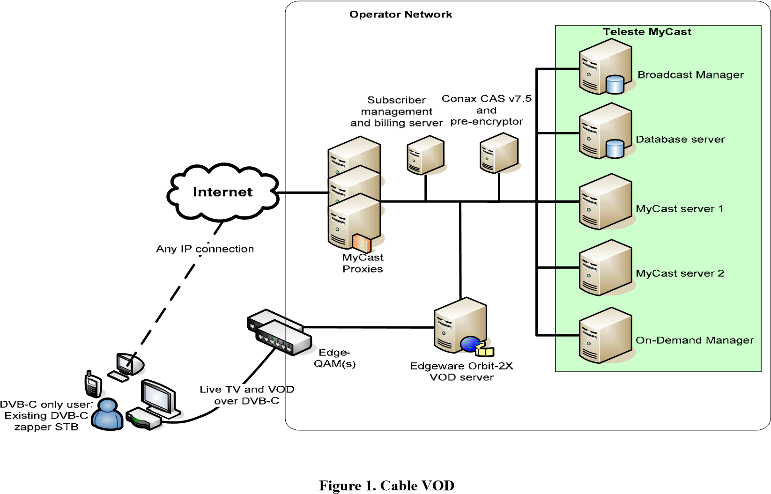
The end user experience can be further enhanced by utilizing hybrid Cable/IP set top boxes. Now the interactivity can be done with a single end user device. The features of the Teleste MyCast will be described more detailed in Appendix 2.

Teleste MyCast’s On-Demand Manager manages the usage of VOD video channel allocation in the cable television network. VOD videos are delivered across the operator’s backbone network as IP all the way to the so-called edge-QAM* devices, which normally reside physically near the end-users. The Edge-QAM device receives the IP unicast and transforms the transmission to QAM. End-users behind different edge-QAMs thus receive different TV channel space but can still share the same logical channel number space. This enables much larger capacity for the whole QAM network and the capacity can be easily enhanced by adding edge-QAM devices.
*See glossary for definition of QAM
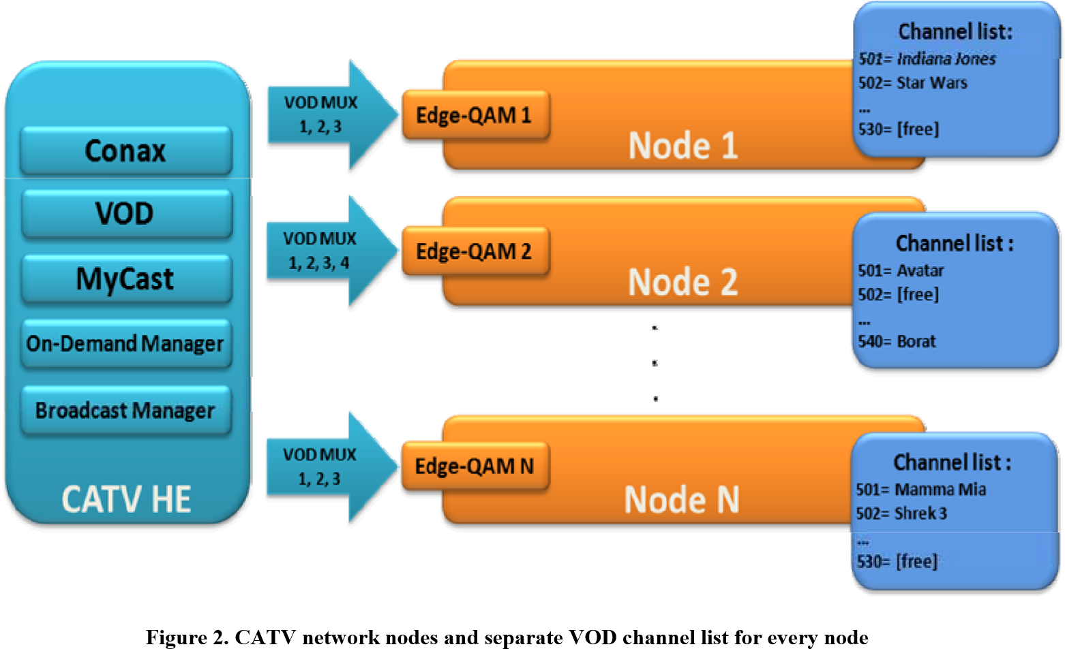

System provides comprehensive tools for easy title and asset management.

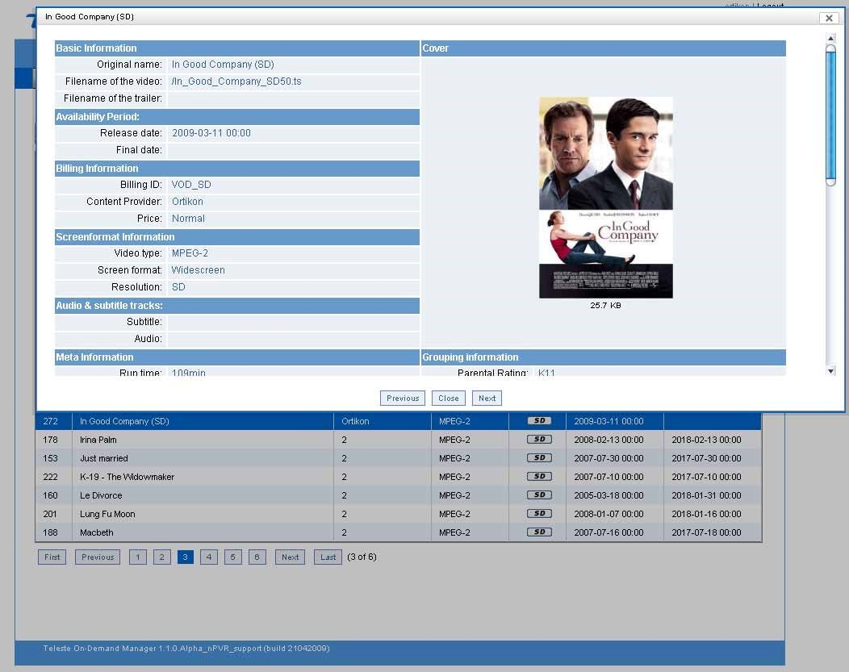

Figure 3. VOD title management

End-user can easily use standard PC or mobile phone for on-demand content browsing, selection, ordering, and finally also for playout (trickplay) control.
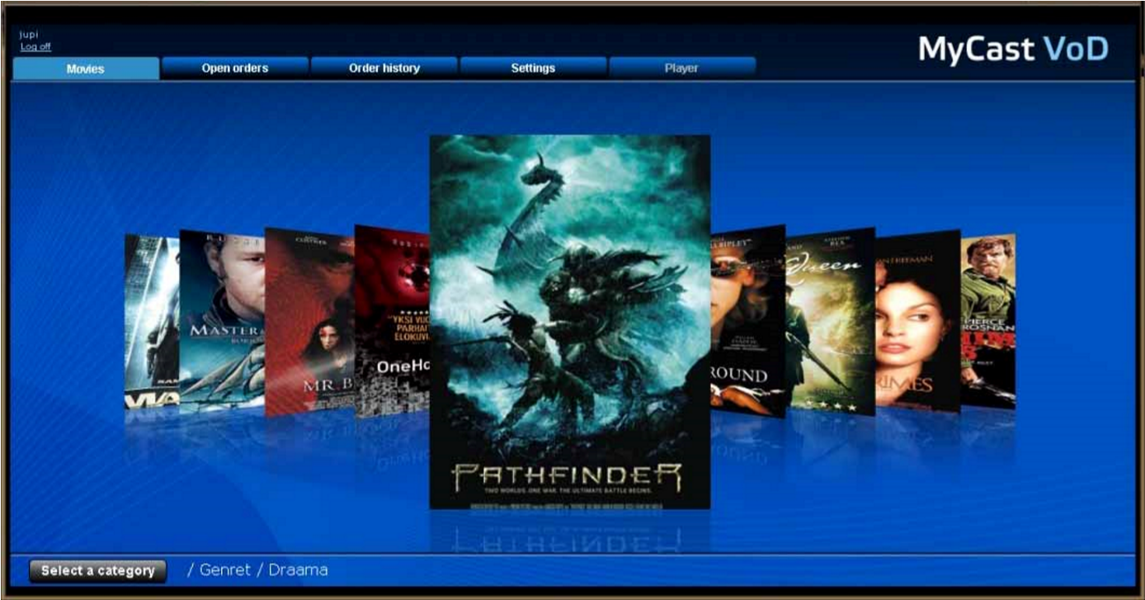

Figure 4. PC VOD portal

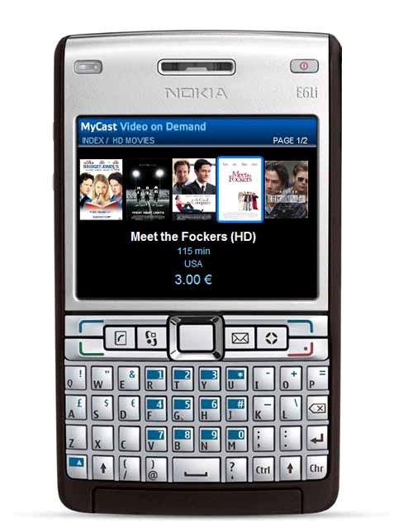
Figure 5. VOD portal in mobile device

Summary
The system developed by Teleste and Edgeware forms a highly scalable, resilient and efficient architecture for the deployment of video and on-demand TV services over cable to provide sophisticated video based content across a large base of subscribers or users.

This solution has the principal benefit of allowing the operator to introduce competitive and compelling services without the need to radical change or investment in the network infrastructure. This in turn means that the operator can introduce these new services quickly and efficiently, resulting in a more easily justifiable and achievable return on investment

APPENDIX 1: EDGEWARE DISTRIBUTED VOD DELIVERY ARCHITECTURE

The Orbit-2X platform forms an integral part of Edgeware’s Distributed Delivery Architecture described below.

The Edgeware Distributed Delivery Architecture (Edgeware DDA) is made up of 3 main components, all of which are closely integrated to form a coherent and integrated architecture:

Orbit hardware platform
By designing a purpose built system Edgeware has been able to build a platform that meets and exceeds the most stringent requirements for distributed implementation in a carrier or operators network infrastructure:

- highly scalable capacity for both storage and forwarding capacity that far exceeds more generic hardware based systems o up to 20Gbps output streaming sustained
o over 16,000 or 32,000 concurrent streams depending on application and bandwidth of stream

- extremely low power consumption o 85W peak power consumption at full configuration, max load

- high capacity, high reliability storage o From 256 Gbytes to 6 TBytes solid state NAND Flash

- dramatically lower complexity of implementation by eliminating the need for costly load balancing, external firewall and other interconnection equipment

...and all of this available in a 1RU half depth 19 inch rack unit.

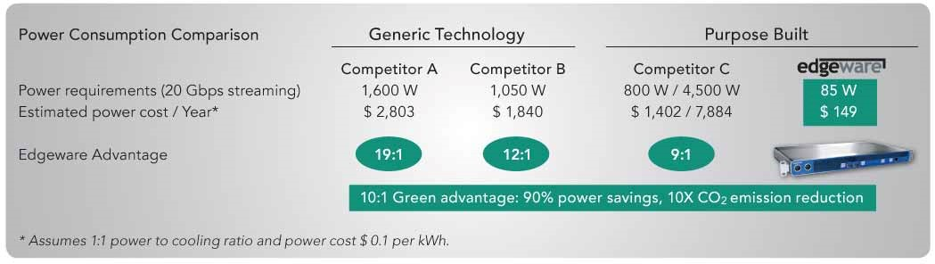

The Orbit hardware platform is delivered in two distinct product sets at this point:

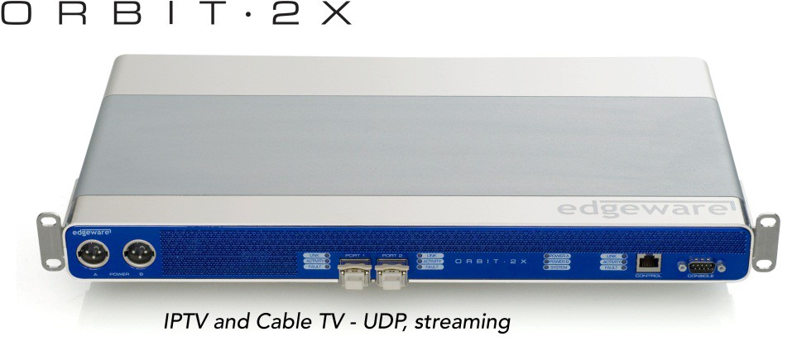

Orbit-2X and Orbit-2G
This product set is focused on providing Video on Demand, IPTV with Time-
shift TV and n-PVR type services primarily to cable and telco operators.
Orbit-2X provides 20 Gbps of output streaming (sustained) for very high scalability and capacity.
Orbit-2G provides 2 Gbps of output streaming for distributed locations where only gigabit Ethernet connectivity is available.

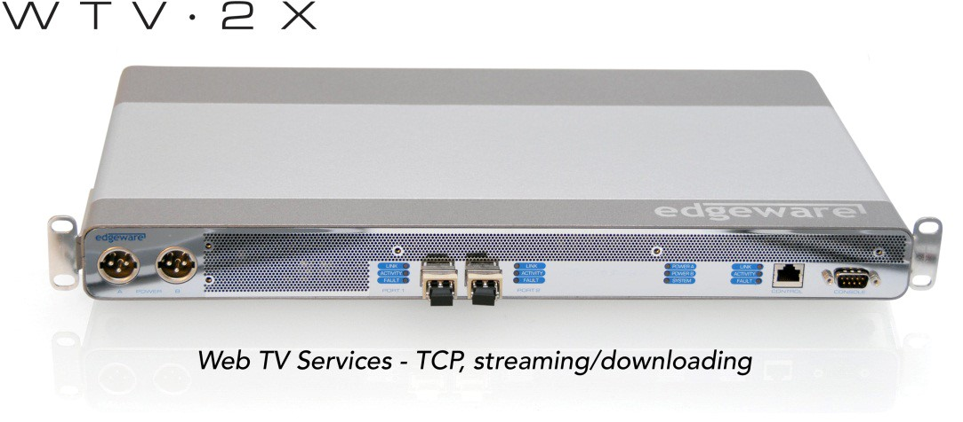

WTV-2X and WTV-2G
This product set provides a focused solution for:
- multi-media content providers to offer over the top (OTT) services to subscribers using a broadband internet connection
- network providers looking to offer premium OTT services to their subscribers
- network providers looking to offer video based CDN capabilities to content providers within their own network
WTV-2X provides 20 Gbps of output streaming (sustained) for very high scalability and capacity.
WTV-2G provides 2 Gbps of output streaming for distributed locations where only gigabit Ethernet connectivity is available.

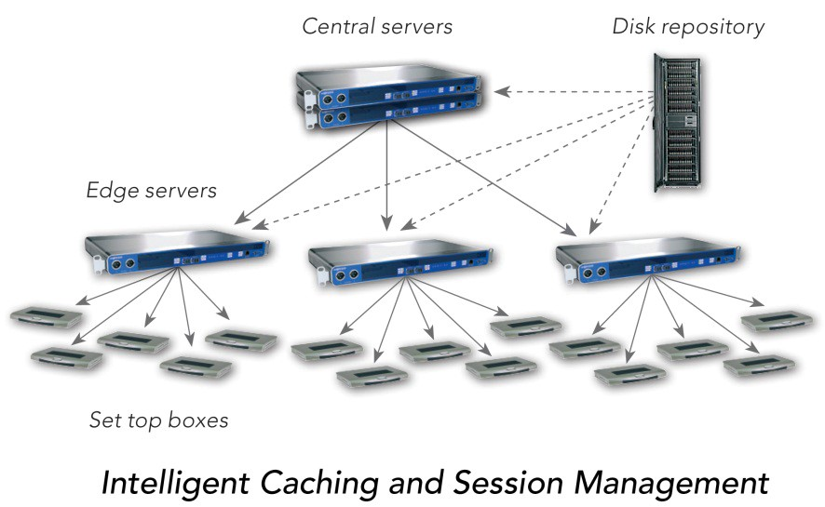

Convoy Distributed Asset Propagation System

Convoy is a fully distributed asset propagation system that is an integral part of each Edgeware server. Each server in the network collects usage statistics based on the requests entering that specific server. This information is then used to decide which content should be available locally. When popular content is not available in the local content repository, it is automatically downloaded from the central server, while the least popular content is removed.

When an edge server receives a request for content not currently available locally, the request is forwarded to the central server through the use of standard RTSP/HTTP signalling.

The Convoy system together with the Origin management system is also responsible for two other critical pieces of functionality across the Edgeware DDA system:

Ad Insertion
One of the most attractive commercial opportunities with On-Demand TV is the possibility for targeted advertisement insertion. Using this capability of providing a unique video stream to each user, commercial content can be tailored for individual users based on different criteria. Edgeware’s sophisticated virtual asset handling, which allows playlists to be created from existing assets and be used to create virtual assets and new channels as well as managing insertion into existing streams is now being integrated with the major ad management systems to allow seamless integration into these environments supporting current and emerging standards such as SCTE 30/35 and SCTE 130.

Fast Channel Change
Fast channel change overcomes the problem of significant length of time between user action (pressing channel change key) to actual channel change on the screen. This is especially important when distributing HD content which has longer periods between the I-frames used for video synchronization. This can result in channel change times of 2-8 seconds under some circumstances. Edgeware solves this problem using dedicated Fast Channel Change application software that is deployed into any of the Orbit family. The standards based solution makes use of inherent multicast ingest capability that can also be used to deliver different types of Time Shift TV services in the same multi-service appliance. Bandwidth for Fast Channel Change and VOD/Time shift TV are licensed separately and any combination of the two services is possible, as long as the total bandwidth does not exceed 20 Gbps per server.

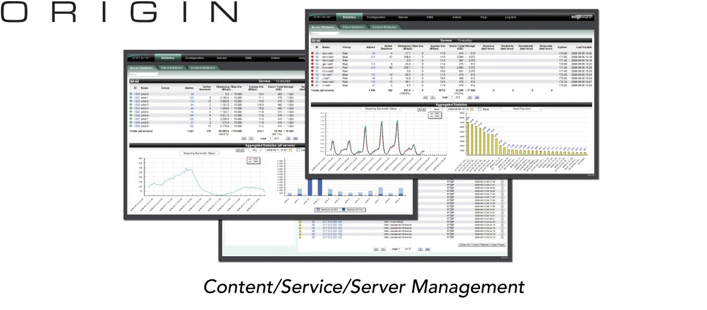

Origin Management System

The Origin Management System provides management and monitoring of the Edgeware Distributed Delivery system as a whole. It consists of 3 modules that can be used individually or as a complete system:
Monitoring - Origin provides tools for monitoring system usage and fine tuning for optimal use of the network resources and the settings of the EDDA system.
Content Management - this module provides a simple ingest path and management system for assets and metadata into the video servers. Assets can be physical files, virtual assets (playlists) or live TV streams with associated recording schedules. The system allows compatibility checking, configuration of automatic ingest of uploaded content and the management of metadata as well has providing proactive warning of any condition that could impact the service.
Configuration - Origin can be used in combination with local web configuration tool, by providing access to the local configuration pages on each video server.

In Summary
The Edgeware Distributed Delivery Architecture provides a highly scalable, resilient and efficient architecture for the deployment of video and on-demand TV services by cable, telco operators and providers. It can also be used by large OTT content providers to deliver services such as hospitality and commercial content. In short, anyone needing to provide sophisticated video based content across a large base of subscribers or users.

Edgeware’s unique approach of ultra-efficient architectural components, combined with its inherent high performance and low cost of ownership means that the road to profitability for offering these services can be dramatically shortened and the return on investment becomes both easily justifiable and it’s achievement significantly more secure.

APPENDIX 2: TELESTE MYCAST
1. Teleste MyCast hybrid TV solution

Teleste MyCast is a hybrid TV solution for managing and distributing TV channels and services. Teleste MyCast supports DVB and IPTV solutions as well as hybrid DVB + IPTV, where TV channels and ondemand video can be broadcasted via DVB or IP, while interactivity happens through IP connection.
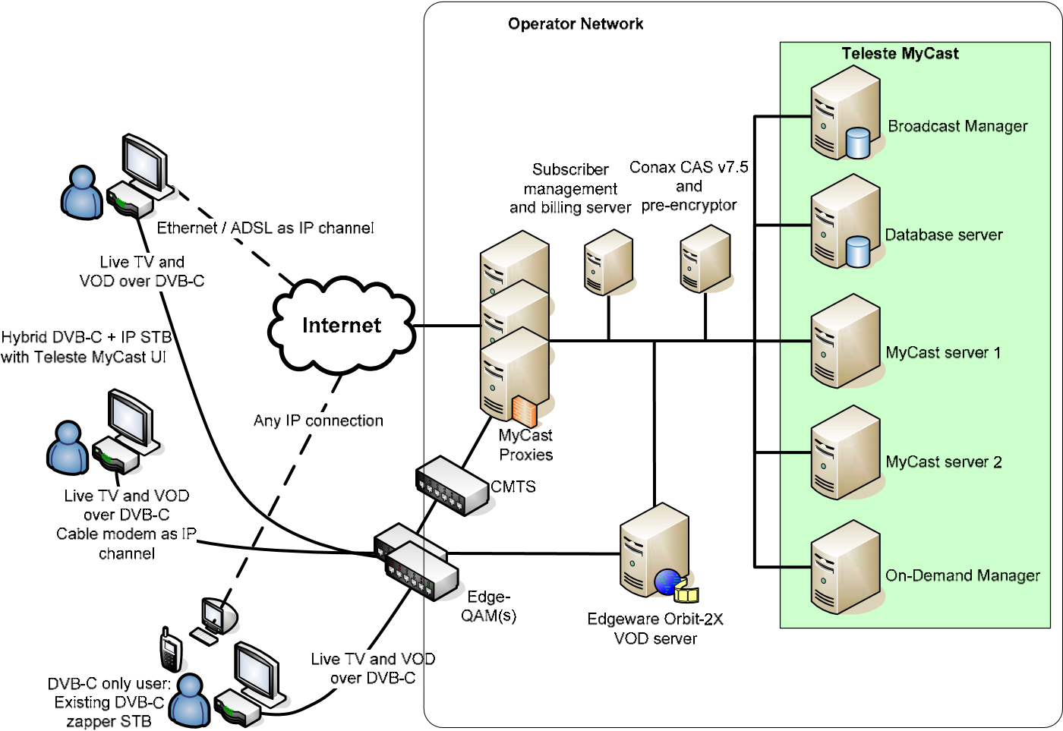
Teleste MyCast can be divided into end-user services and management tools. The solution has a modular architecture and more services can be added later on as the system grows by utilizing advanced API’s. Service applications consist of 1) end-user services provided to subscribers and 2) management applications for operators with full control over the services management.
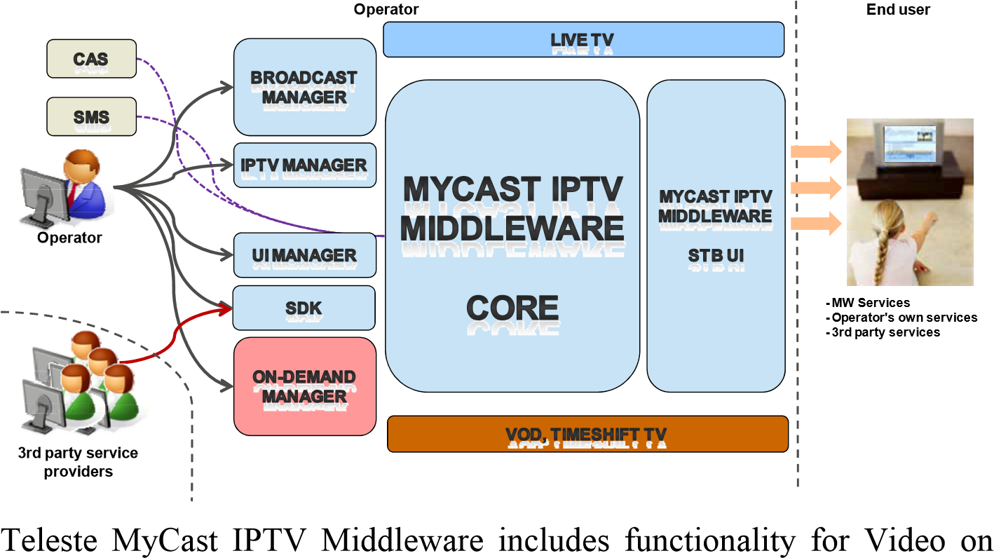
Demand (VOD) services. VOD enables operator to provide end-users with library of video of video assets through VOD portal and a possibility to order a VOD title and control its playback.
For more information about Teleste MyCast, please visit http://www.telestemycast.com.

APPENDIX 3: TELESTE
MYCAST SCREENSHOTS

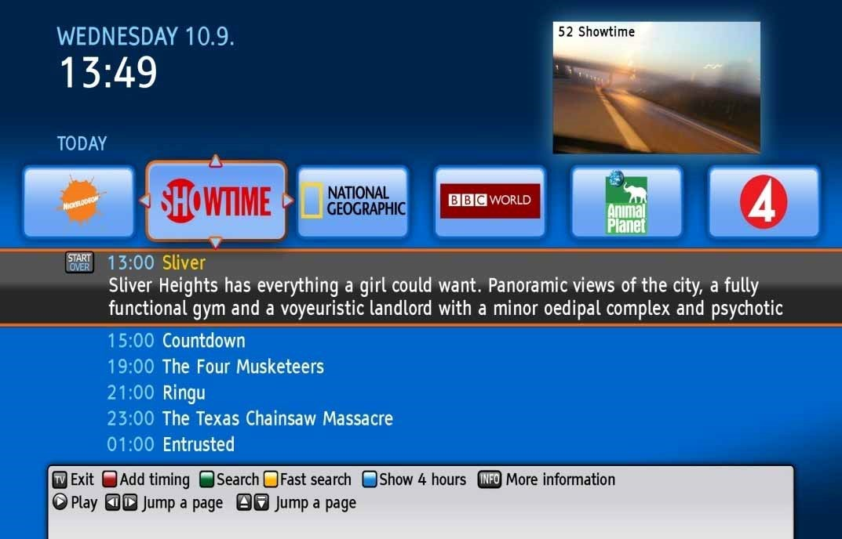
EPG
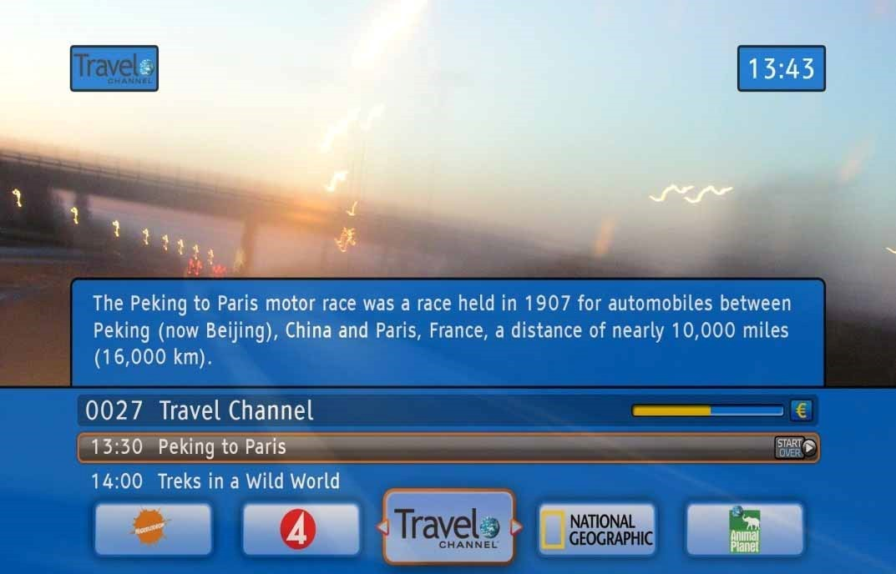
Channel info

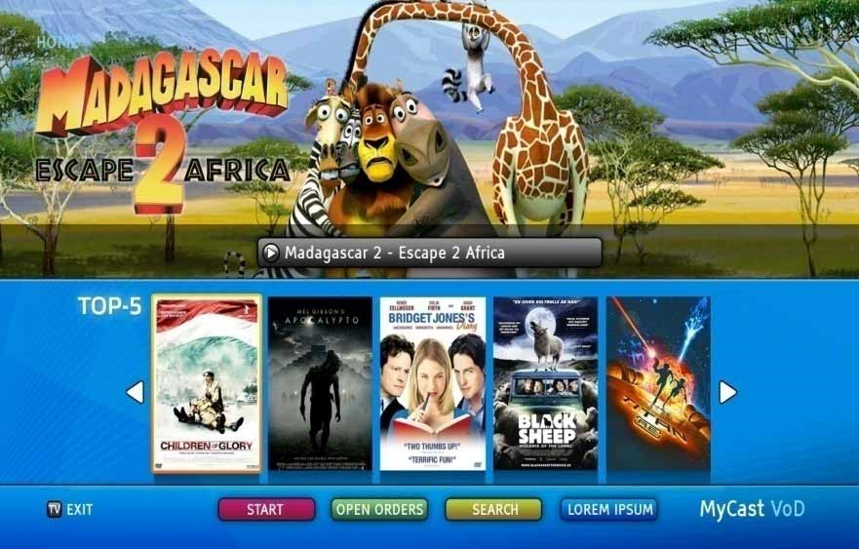
VOD portal – Main page

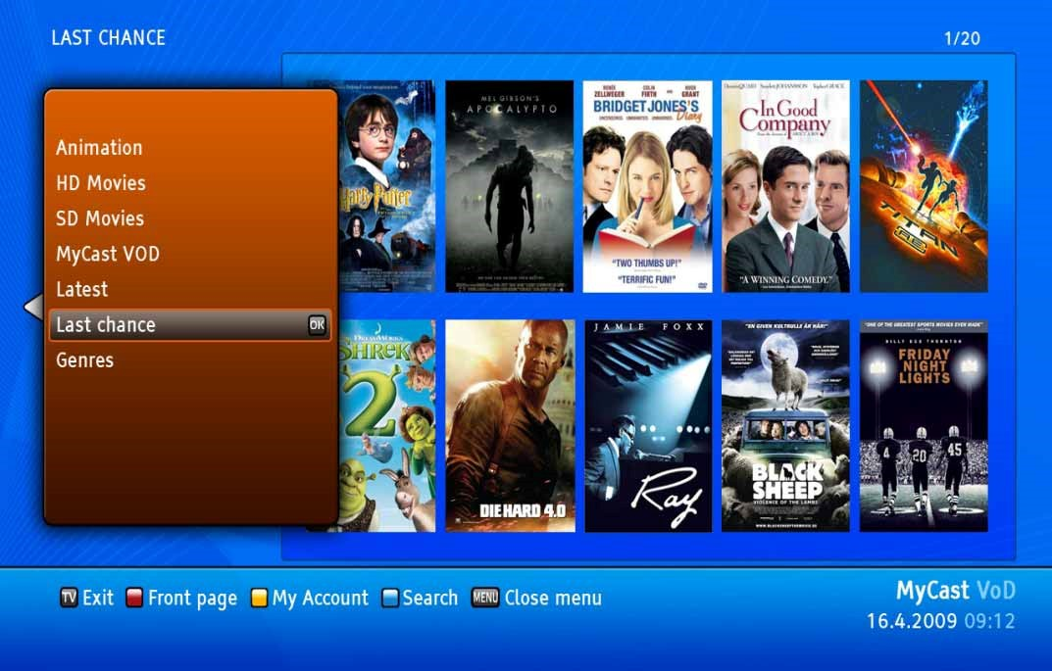
VOD portal – Movie selection

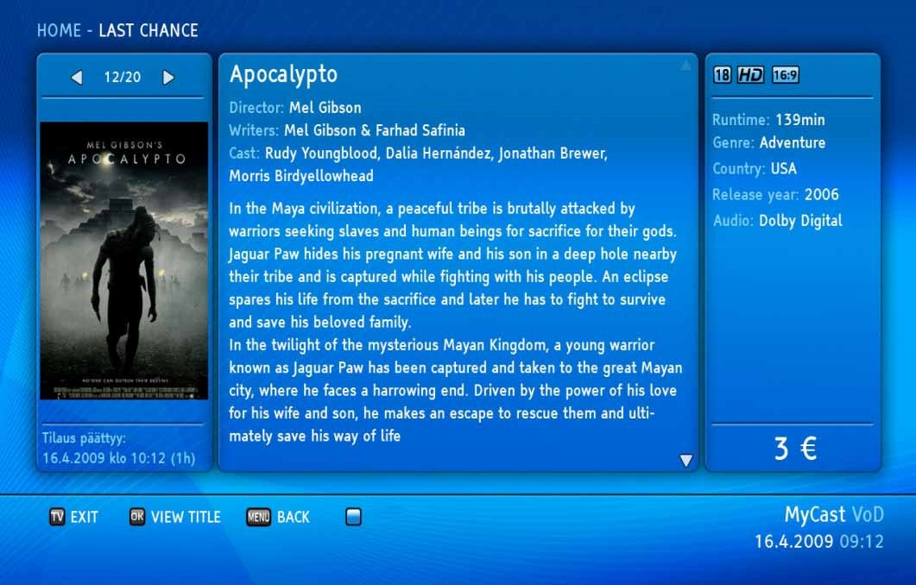
VOD portal – Movie information
Graphical user interface of the VOD portal can be tailored according to Operator’s needs.

